TA Immunology
Call for Proposals
The primary goal of our unit is the identification of highly effective, innovative drug development candidates for the treatment of rheumatoid arthritis, inflammatory bowel disease or psoriasis, with the potential to extend the therapeutic use to additional auto‐inflammatory conditions.

What We Are Looking For
We are searching for scientific collaboration opportunities in these indication areas that can complement the expertise and activities with our in‐house laboratories. Opportunities could include a range of aspects, with a focus on novel target ideas, but also extending to novel assay systems and translational models or biomarkers. We are particularly interested in:
- Novel targets and approaches to treat autoimmune diseases (e.g. T_{reg} enhancement, anti-inflammatory pathway stimulation; strong focus on cytokine/cytokine receptor biology and checkpoint modulators).
- Multi‐specific biologics approaches to address refractory patients and to achieve improved efficacy in autoimmune diseases (including (disease)-tissue targeting approaches to achieve higher efficacy and improved safety; focus on RA but also other indications possible).
- Quantitative systems pharmacology to better characterize and validate combinatorial targets and pathways
- Development of complex cellular in vitro co‐culture system(s) able to reflect key processes of the physiological or pathological situation in healthy or arthritic synovial tissue, respectively.
- Targeting T cell metabolism to modulate the immune response in autoimmune diseases (e.g. via regulating mitochondrial function).
- Analysis of responders/non‐responders (e.g. to anti-TNF therapy) in RA, IBD, AD, and PsA.
- Systemically measurable biomarkers beyond CRP for anti‐inflammatory therapeutics.

How To Prepare And Submit Your Proposal
- Fill in the proposal template provided by Sanofi or your contact person at the Charité, MDC or BIH.
- The application should not exceed 3-4 pages in total.
- Submit the completed project proposal template to:
  - Charité:. Abigail Garner, abigail.garner@charite.de
  - MDC: Dr. Gerd Müller; g.mueller@mdc-berlin.de
  - BIH: Dr. Janna Hachmann, janna.hachmann@bihealth.de

- Deadline: Friday, April 28th 2017

The Selection Process
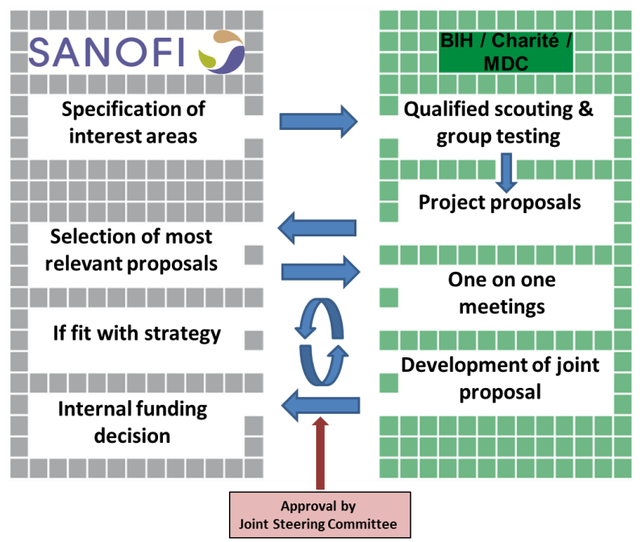
Inflammatory Bowel Disease
Ankylosing Spondylitis
Rheumatoid Arthritis
Psoriasis
Type 1 Diabetes
Atopic Dermatitis
Asthma
Psoriatic Arthritis

Initiator: Sanofi-Aventis Deutschland GmbH, Industriepark Höchst, 65926 Frankfurt am Main
Strategy & Business Development, Alliance Management
Dr. Bernd Jablonka | +49 69 305 5955 | bernd.jablonka@sanofi.com

